**How to Navigate the Resources & Benefits page of our website.**

​

**1. Login to the Big I Illinois website at** [**http://www.ilbigi.org**](http://www.ilbigi.org)**.**

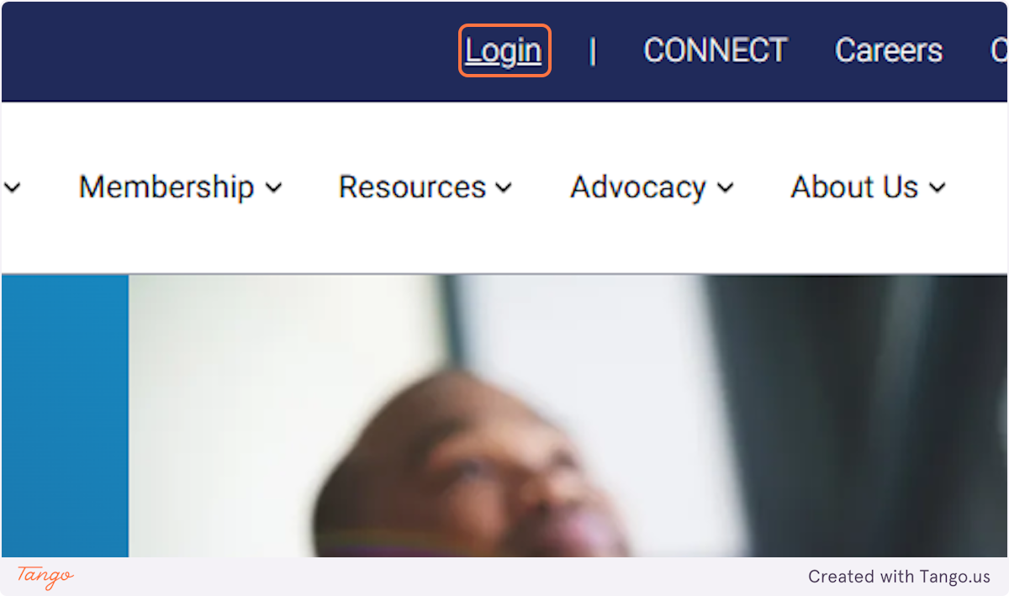

**2. Hover over the membership tab.**

Mobile users, click the three lines menu in the upper right hand corner to expand the menu.

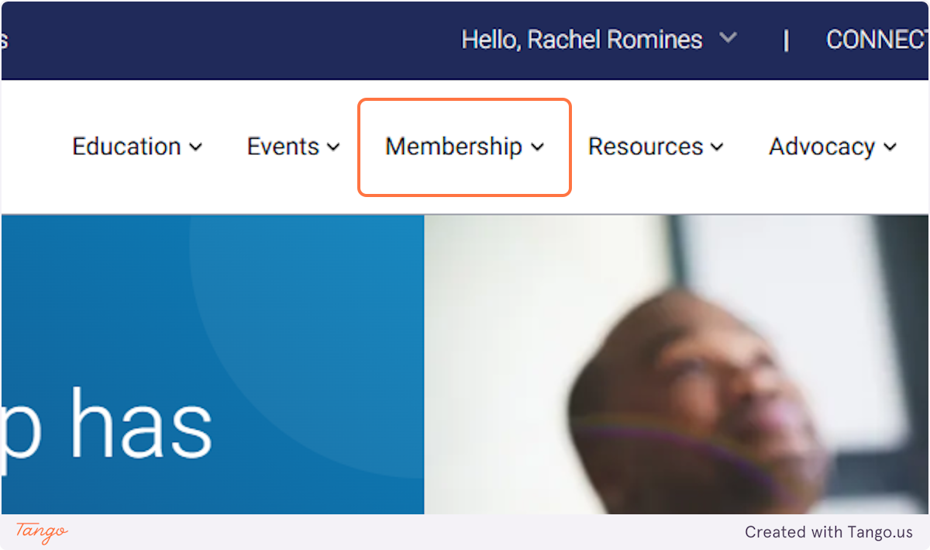

**3. Click on Benefits, Products, Resources, and Services**

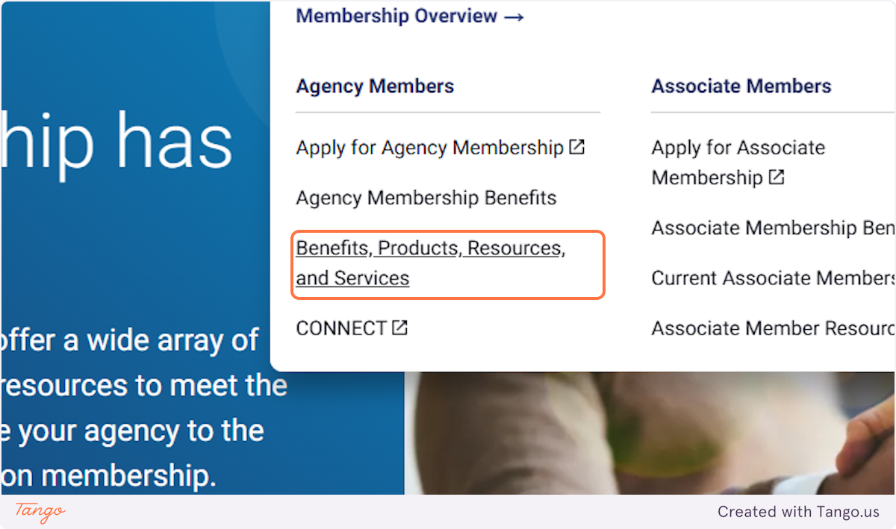

**4. Scroll through page by page or use the categories or filters.**

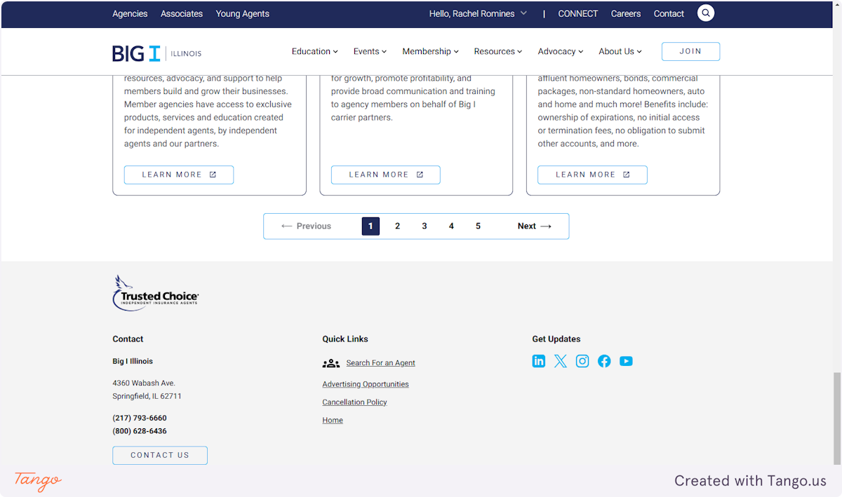

**5. Check out all the filter options.**

Review the cards that show.

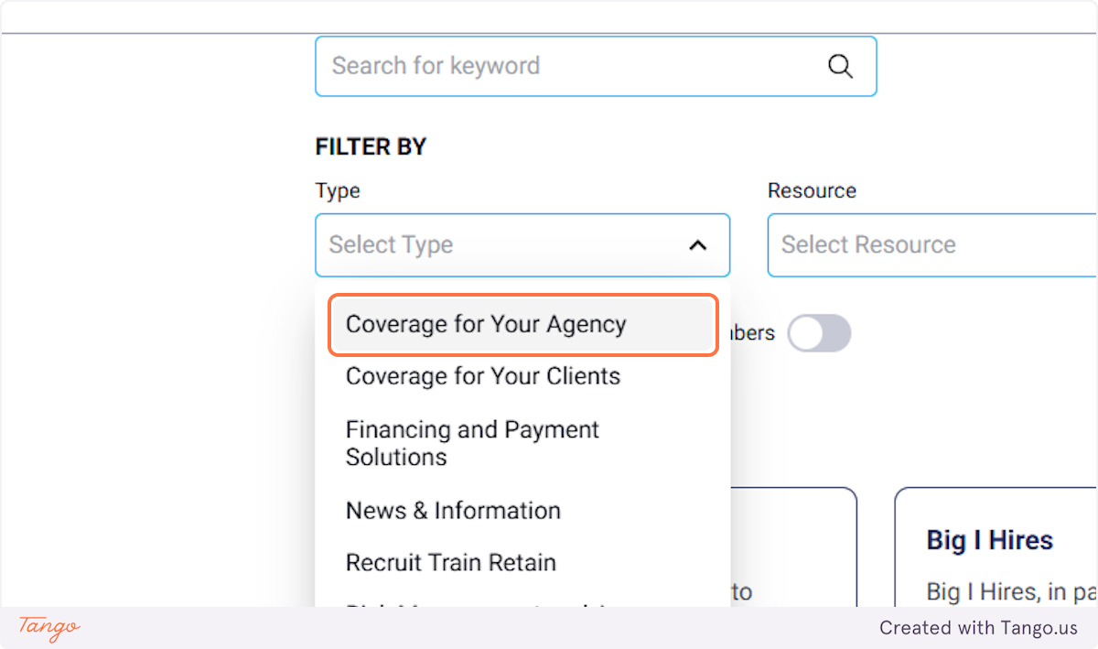

**6. To remove any filter, click on ✕**

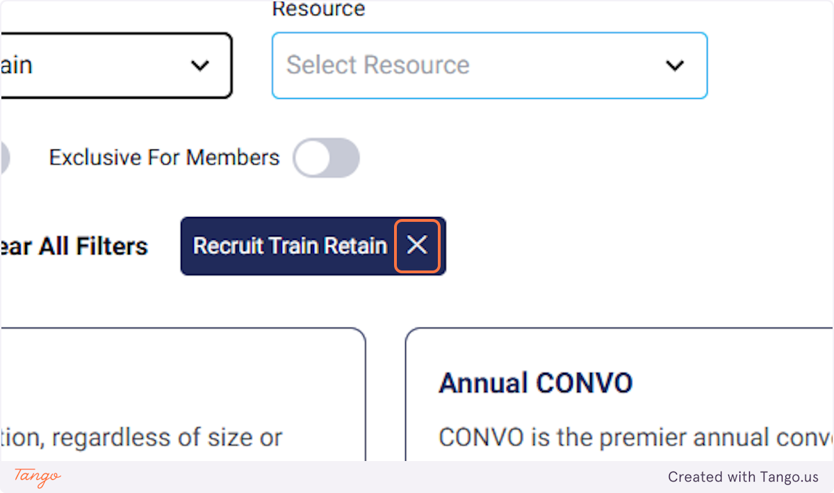

**7. You can also enter a search term that to find what you need.**

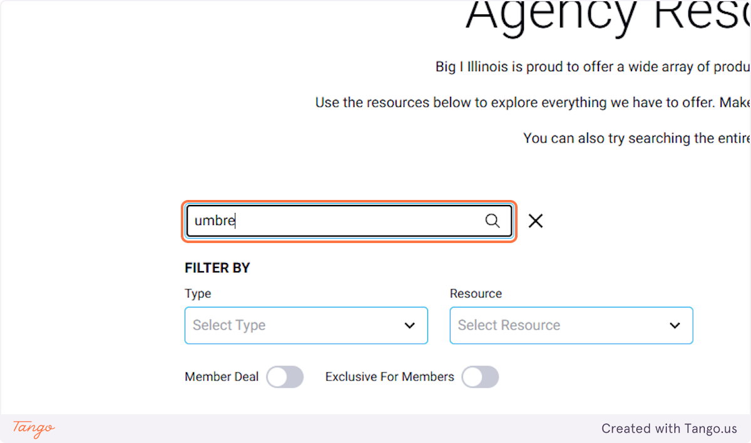

Created with [Tango.ai](https://tango.ai?utm_source=magicCopy&utm_medium=magicCopy&utm_campaign=workflow%20export%20links)