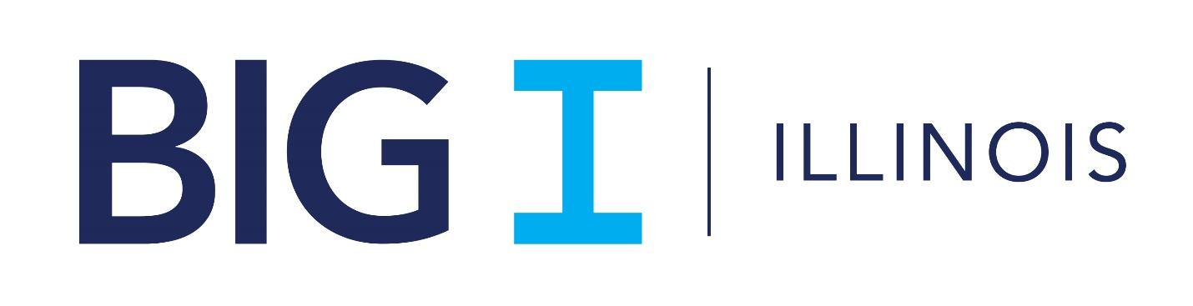

2021
Diversity, Equity, and Inclusion
Resource Guide

How To Use The DEI Resource Guide

The Diversity, Equity, and Inclusion (DEI) Resource Guide is a major step on the Association’s emerging 2021 DEI Initiatives. The Guide includes references to best practices, reports, websites, books, articles, and other media to inform and educate you on the various issues that pertain to DEI. The Guide can be your "go to" DEI resource.
We hope you will use the Guide in formal and informal conversations and will consult it if you have questions about how to approach these sometimes sensitive topics. As the Association moves forward with its DEI Initiatives, we will regularly update the Guide, so we encourage you to check our website for new resources.
This is an exciting time for Independent Insurance Agents of Illinois and we want DEI to become synonymous with our expectations for excellence!
Regards,
Phil Lackman, CEO
George Daly, President (2020-2021

Table of Contents

Why Diversity Matters / Basic Diversity Resources 4
Why and How Inclusion Matters 5
Privilege / Microaggressions 7
Implicit Bias / Unconscious Bias 8
Employee Resource Groups / Mentorship 9
Showing Up Authentically / Recruiting 9
Other General DEI Resources 9

Why Diversity Matters / Basic Diversity Resources
Resources to understand basic DEI concepts and the business case for DEI programs.
Websites
- Why Diversity Matters (pdf) (McKinsey and Company, 2015)

- Why Diversity Matters - Diverse Workforces Perform Better Financially (McKinsey and Company, 2015)
- Why Diversity and Inclusion Matter (Catalyst, 2020)
- Delivering Through Diversity (McKinsey and Company, 2018)

- Companies Need to Think Bigger Than Diversity Training (Harvard Business Review, 2020)

- Why Diversity Programs Fail (Harvard Business Review, 2016)

- What Diversity Metrics are Best Used to Track and Improve Employee Diversity?

- Practical stance needed on diversity, inclusion (Business Insurance, 2020, subscription required)

- Conservative Culture Stymies Efforts to Diversify Insurer Executive Leadership (Carrier Management, 2020)

- Starbucks ties executive pay to meeting diversity goals (2020)

Books
The Loudest Duck: Moving Beyond Diversity while Embracing Differences to Achieve Success at Work, Laura A. Liswood

Between the World and Me, T’Nehisi Coates

Podcasts
- “The Will to Change: Uncovering True Stories of Diversity and Inclusion” hosted by Jennifer Brown
- The Diversity Gap hosted by Bethaney Wilkinson
- Diversity Deep Dive
- Diversity Beyond the Checkbox hosted by Donald Thompson

“Diversity is a mutual understanding, appreciation, and respect for an individual's unique differences.”

Why and How Inclusion Matters
Resources that explain why inclusion is a critical part of culture change and prospects for growth.
Websites

- Diversity Wins; How Inclusion Matters (McKinsey and Company)
- Diversity vs Inclusion in the Workplace (Betterteam, 2020)

Books
- Better Allies: Everyday Actions to Create Inclusive, Engaging Workplaces by Karen Catlin
- How to be an Inclusive Leader: Your Role in Creating Cultures of Belonging Where Everyone Can Thrive by Jennifer Brown
- Belonging: The Key to Transforming and Maintaining Diversity, Inclusion and Equality at Work by Kathryn Jacob, Sue Unerman and Mark Edwards

Podcasts
- The Next Pivot hosted by Julie Kratz
- The Element of Inclusion hosted by Jonathan Ashong-Lamptey

Equity versus Equality
Resources that explain the fundamental differences between equity and equality.
Websites

- Equity vs Equality: What is the Difference (Mental Floss)
- Equity vs Equality (Winston Salem State University)
- The Difference Between Workplace Equity And Equality, And Why It Matters (Forbes)
- Do Your Employees Know Why You Believe in Racial Equality (Harvard Business Review)
- Moving Beyond Diversity to Racial Equity (Harvard Business Review)

Privilege / Microaggressions
Resources to understand the historical impact of privilege and the effects of microaggressions.
Websites

- Understanding Microaggressions (handout) (Association of American Medical Colleges)
- Racial Microaggressions in the Workplace (Forbes)
- The Importance of Understanding Microaggressions at Work (Culture Amp)

- The Privilege Not Understanding Privilege

Books
- Privilege, Power, and Difference by Allan G. Johnson
- So You Want to Talk About Race by Ijeoma Oluo
- White Fragility: Why It’s So Hard for White People to Talk About Racism by Robin DiAngelo
- 35 Dumb Things Well-Intended People Say: Surprising Things We Say That Widen the Diversity Gap by Maura Cullen
- Subtle Acts of Exclusion: How to Understand, Identify, and Stop Microaggressions by Michael Braun and Tiffany Jana

Podcasts
- Code Switch hosted by NPR
- Women’s Hour Daily hosted by BBC

“Recognition of difference is important for providing people with the sense of deference they're inherently worth.”
IIAIL DEI Survey participant, 2020

Implicit Bias / Unconscious Bias
Resources to explore aspects of bias, defined as “prejudice in favor of or against one thing, person, or group compared with another, usually in a way considered to be unfair.”
Websites

- Implicit Bias Resources (UCLA)
- Implicit Association Test (Harvard)
- Proven Strategies for Addressing Unconscious Bias in the Workplace (Cook Ross)

Books
- Messengers: Who We Listen To, Who We Don’t, and Why by Stephen Martin and Joseph Marks
- Sway: Unravelling Unconscious Bias by Pragya Agarwal
- How to Be an Antiracist by Ibram X. Kendi

Podcasts
- Code Switch hosted by NPR
- Women’s Hour Daily hosted by BBC

Employee Resource Groups / Mentorship
Resources to guide the formation of mentoring programs and Employee Resource Groups (ERGs).
Websites

- How to encourage diversity and inclusion with employee resource groups
- Best Practices For Effective Utilization of Employee Resource Groups
- Want more diverse senior leadership? Sponsor junior talent.

Books
- Athena Rising: How and Why Men Should Mentor Women | W. Brad Johnson and David Smith

Showing Up Authentically / Recruiting
Resources to inform identification and selection of diverse talent.
Websites

- https://www.forbes.com/sites/garrettgunderson/2020/06/30/a-leaders-guide-to-showing-up-authentically-at-work/#6b1a15e21226
- https://rallyrecruitmentmarketing.com/2019/10/how-to-show-your-authentic-employee-experience/
- https://www.brazen.com/resources/your-candidates-want-authenticity-and-heres-how-to-give-them-what-they-want

Other General DEI Resources
Current information to build knowledge and awareness about DEI.
Websites

- Identity Development Models
- The Journey of the African American Insurance Professionals, by Dr. Leroy D. Nunery II

“We continuously survey and discuss the business needs of our customers/clients. Thus, one of the reasons we maintain a high customer retention ratio. We understand that the younger generations are more tech savvy than older ones. We endeavor to treat all of our clients with the same dignity and respect.”
Comment by IIAIL DEI Survey participant, 2020

