**How to Make a Post on CONNECT**

​

**1. Login to the Big I Illinois website at** [**www.ilbigi.org**](http://www.ilbigi.org)**.**

Only agency members have access to CONNECT.

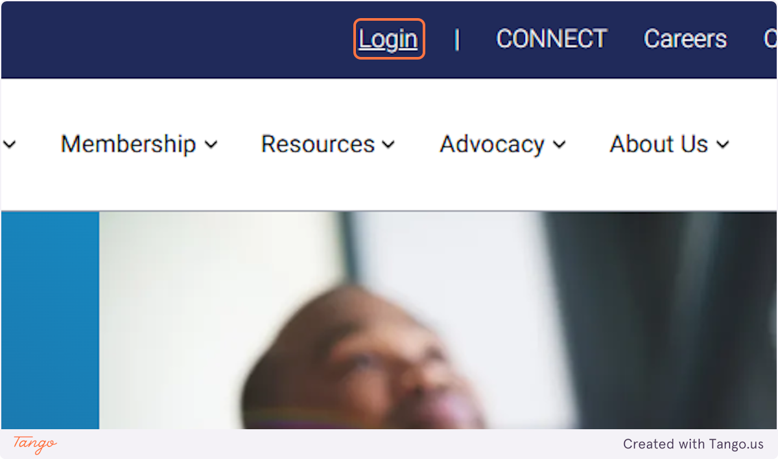

**2. Once logged in, click on CONNECT**

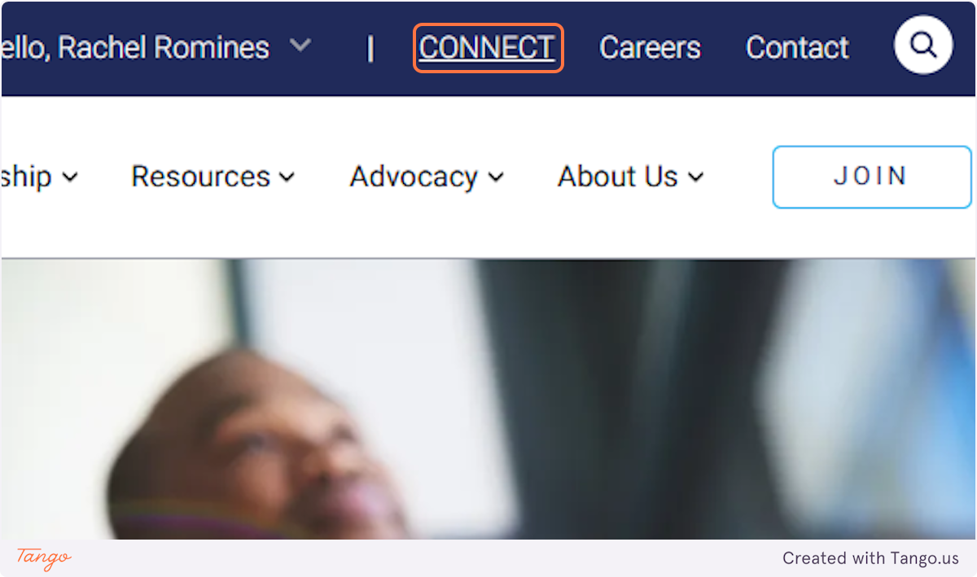

**3. This is your dashboard.**

Explore the area! This is your starting point.

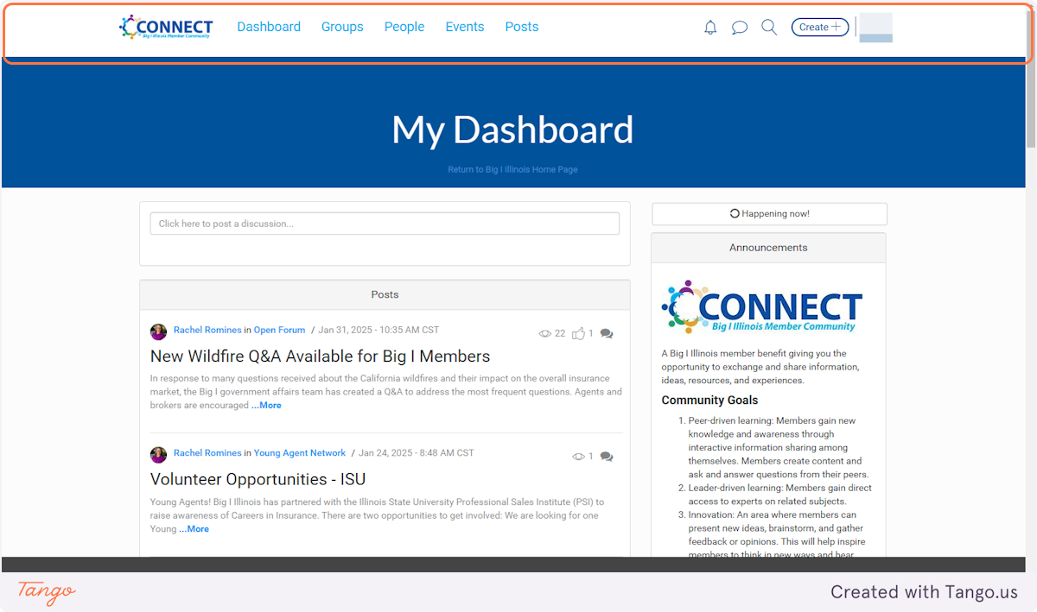

**4. To add a post, simple start with your Subject text.**

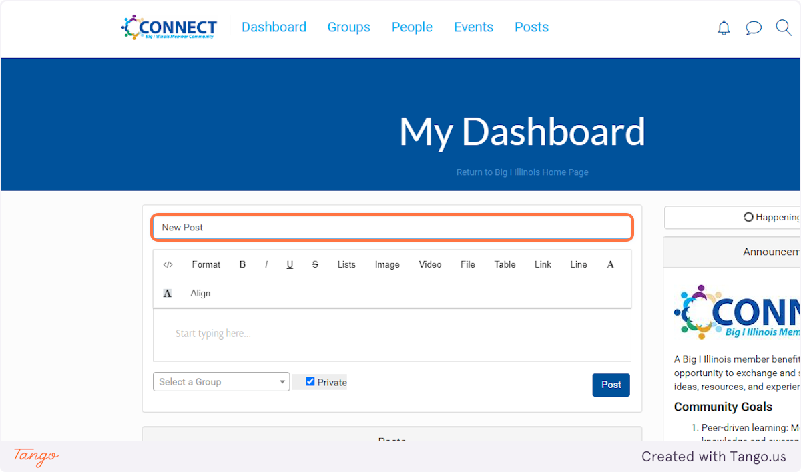

**5. Type in the editor.**

You can include links, files, and more.

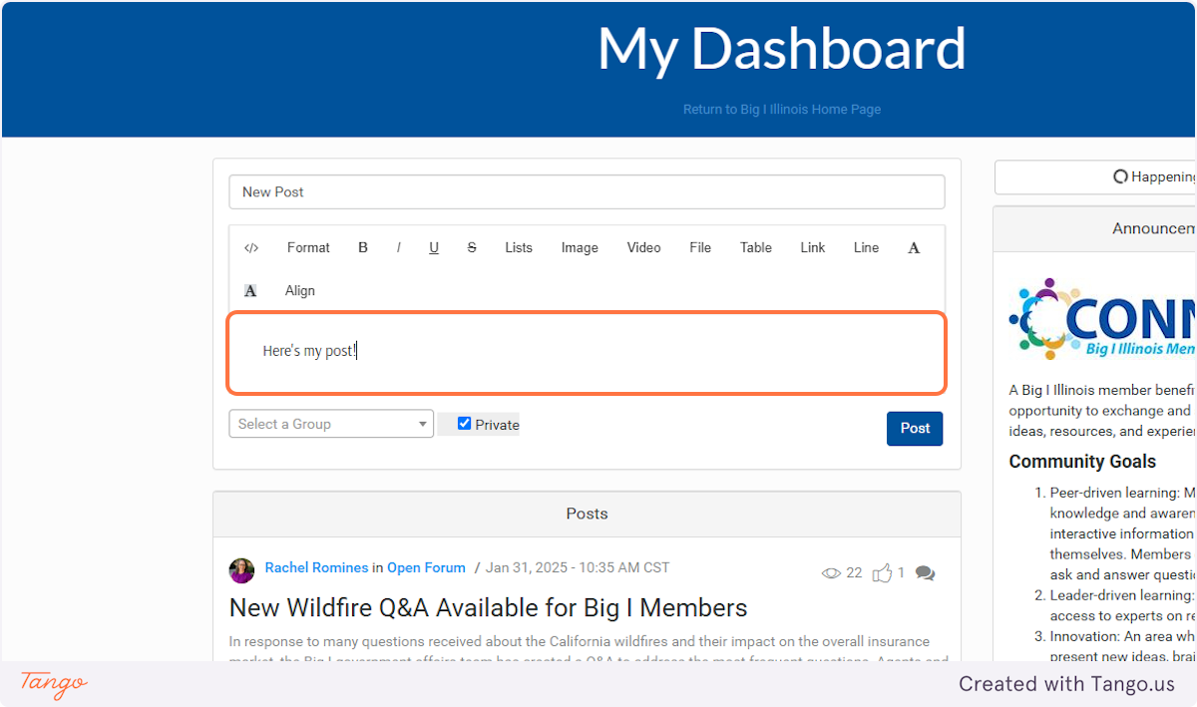

**6. Click on Select a Group**

You'll have to select a group before posting. Only the groups you are a part of will be shown in the list.

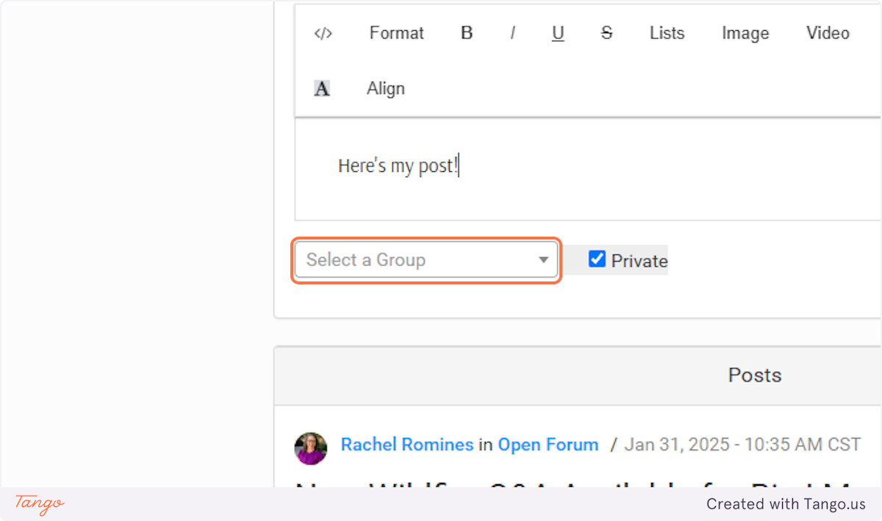

**7. Ready?! Click on Post!**

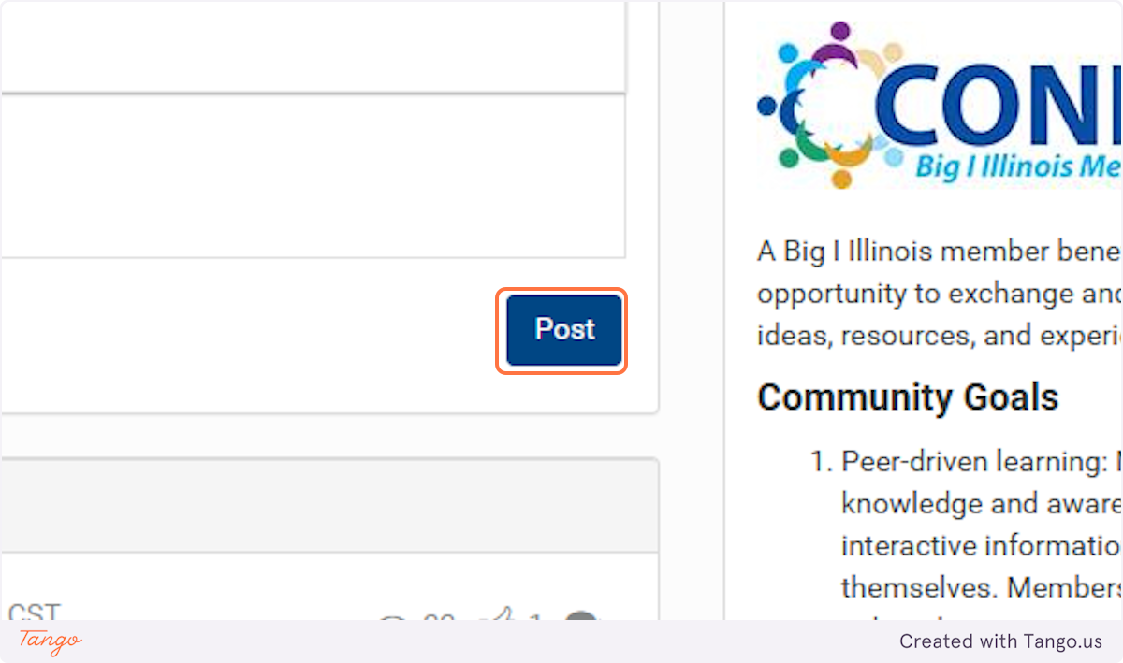

Created with [Tango.ai](https://tango.ai?utm_source=magicCopy&utm_medium=magicCopy&utm_campaign=workflow%20export%20links)