**How to Add Agency Personnel on the Big I Illinois Website**

​

**Login to the Big I Illinois website – www.ilbigi.org**

**1. Once logged in, click on your name at the top, then click My Account**

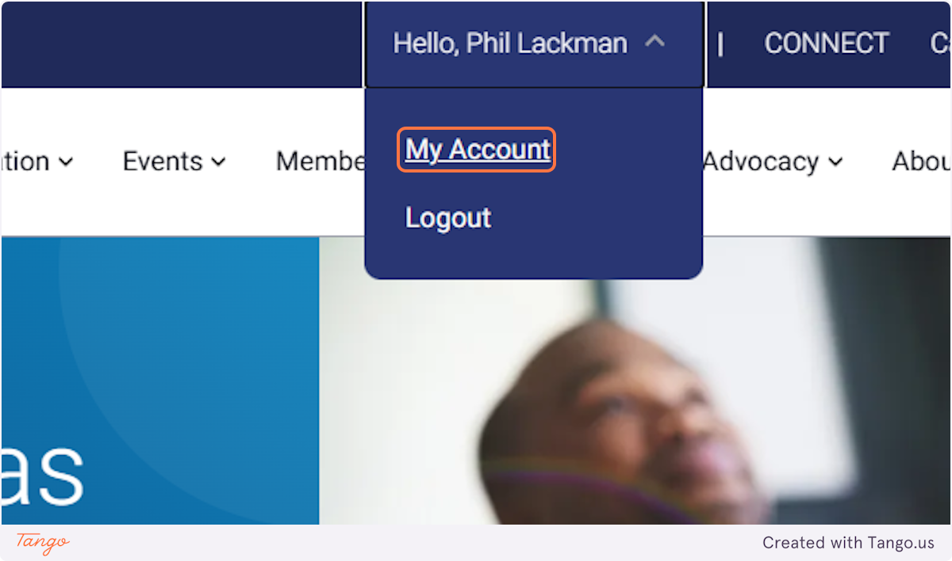

**2. Click on MY COMPANY...**



**3. Then scroll to click on My Company Contacts**

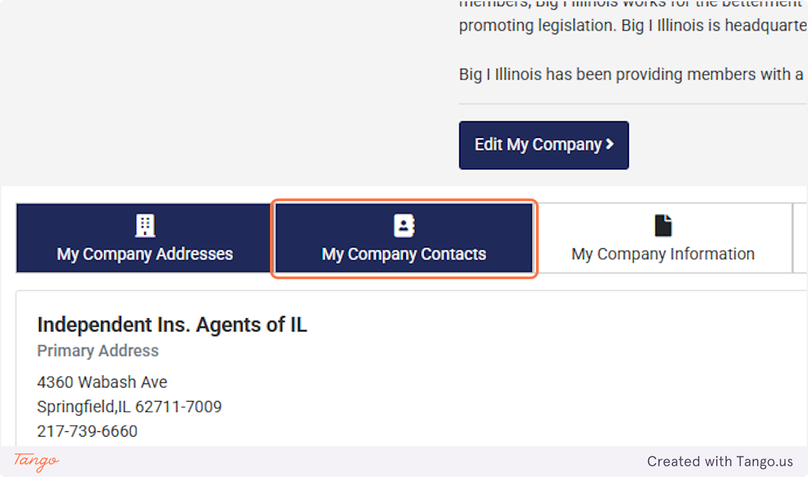

**4. Your Contact List will populate. Click the pencil icon to edit the user. Click the trash icon to delete the user.**

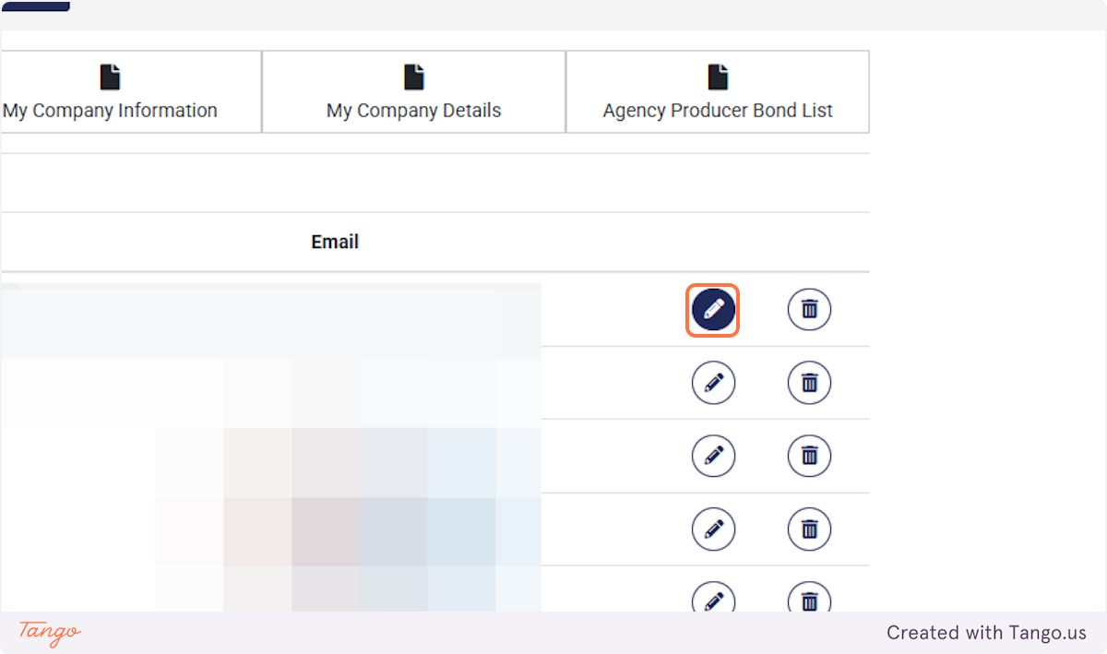

**5. To add additional employees, click on Add New Personnel**

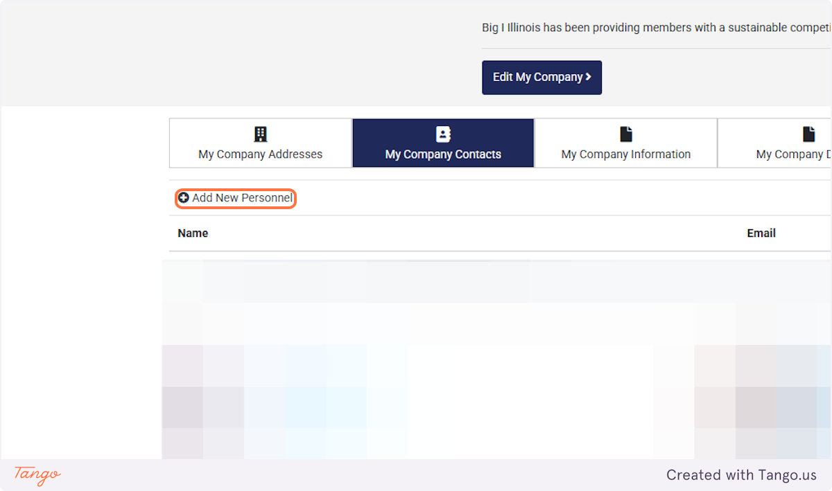

Created with [Tango.ai](https://tango.ai?utm_source=magicCopy&utm_medium=magicCopy&utm_campaign=workflow%20export%20links)